MINDOR Ingredients list:
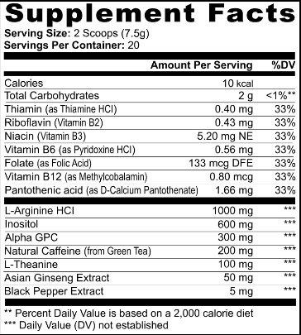

0.40 mg of Thiamin (as Thiamine HCl)
0.43 mg of Riboflavin (Vitamin B2)
5.20 mg NE of NIacin (Vitamin B3)
0.56 mg of Vitamin B6 (as Pyridoxine HCl)
133 mcg DFE of Folate (as Folic Acid)
0.80 mg of Vitamin B12 (as Methylcobalamin)
1.66 mg of Pantothenic acid (as D-Calcium Pantothenate)

1000 mg of L-Arginine HCl
600 mg of Inositol
300 mg of Alpha GPC
200 mg of Natural Caffeine (from Green Tea)
100 mg of L-theanine
50 mg of Asian ginseng Extract
5 mgof black pepper extract

